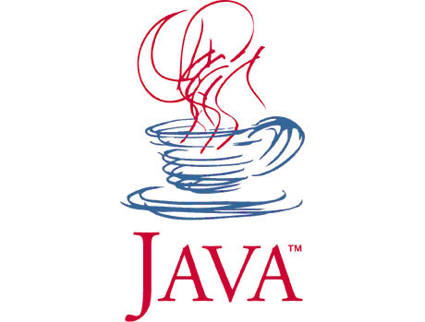****

**Introduction to Programming**

**with Java**

**Class:** **ReverseLines.java**

**Score:** (Easy)

**Description:**

Since strings are sequence of characters, we can store strings in character arrays. To store multiple lines of string, 2 dimensional character arrays are commonly used. Implement a program that reverses lines of a given 2 dimensional char array

**Sample Run:**

This program reverses the lines.

The music is reversible but Time is not.

Congratulations. You have just discovered the secret message.

Messin' with things you don't understand

Reversed Version:

Messin' with things you don't understand

Congratulations. You have just discovered the secret message.

The music is reversible but Time is not.